**MAGADHA EMPIRE**

**Rise of Magadha :**

We can recognize the Rise of Magadha into 4 factors

1. **GEOGRAPHY**

The state / kingdom of Magadha & its first capital Rajgriha (Rajgir) are surrounded by 5 different hills. And , its second capital Pataliputra (Patna) is situated on the banks of Rivers GANGA , GANGTOK , SOAN.

Thus , the travel through Boats from Pataliputra became easier , that led to inter connectivity with other maha janapadas. These rivers acted as the ways for Transport of Goods , Imports & Exports , Trade etc.,

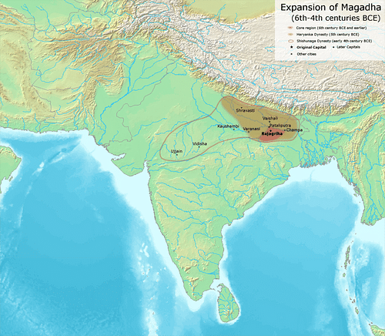The hills are naturally formed and are very strong in nature & acted as Natural Protection for the kingdom. Thus, it became very difficult for invaders or enemies to enter into Magadha territory.

FERTILE LANDS

Alluvial soils are the natural gifts to Magadha Kingdom. They were very fertile to cultivate & gave huge agricultural food , Commercial Cash crops & its surplus. This huge surplus led to the Trade & Commerce , and Magadha people earnt huge profits through performing Trade & Commerce due to heavy surplus availability.

Hence , the King started imposing TAX on Crops , where the farmers should divide their crop yield into 6 equal parts & give 1 part to the King as Tax.

These tax collection made the Kingdom more prosperous.   
The Tax was named as BHAGA Tax , it is the first ever tax collected in the history of Indian Subcontinent.

AVAILIBILITY OF RAW MATERIALS & TIMBER

With the heavy availability of Timber in forest areas , Magadha people started making Boats with them. The transporting & trade of Forest products also boosted the revenue & profits of the people.

LARGE ARMY

KAUTILYA proposed in the SAPTANGA THEORY that a Kingdom needs SAPTANGA (7 LIMBS) to become an Empire. The 7 essential Limbs are

1. **SWAMIN**

It commands that the King should be efficient in Strong Skills , Tactics , Knowledge , Power . It also states that The happiness of a King Should always lies in the Happiness of His people. Else , the kingdom should fall into decline.

Chanakya stated that if the King is not mentally & tactically efficient & strong , the revolutions arises. They may be revolutions by his people , or even by his army .Then , the Minister succeeds the Throne. The more Sustainable King , more the sustainable kingdom. MIGHTY is the RIGHT.

1. **MANTRI**

Not only the King , but the MANTRI (MINISTER) should also be efficient in Suggesting the King in the Dos & Don’ts , and should also be efficient in implementing the ideas of his own or given by the King.

He should act as Subordinate to the King & shouldn’t dominate the king.

1. **KOSHA**

Kosha means TREASURY. The Sustainability of a Kingdom depends on the Revenue it gets . And , the kingdom should have the capability of Securing the revenue . Thus the Treasuries played a vital role in Securing the revenue earnt from trade , commerce , taxes & conquering the other kingdoms .

1. **JANAPADA**

We cannot imagine a kingdom without JANAPADAS (Territories).

1. **BALA**

Bala Means ARMY. A kingdom should be well equipped with 4 forces ASHWA DHALAM (Cavalry / Horse Forces) , PADAATHI DHALAM (Infantry / Human Foot Soldiers) , GAJA BALAM (Elephantry Forces) , RATHA BALAM (Chariotry Forces). These 4 forces are called as CHATURANGA BALALU.

1. **DURGA**

Durga means KOTA (Citadel / Fort). Durga is the centre of Command for all the forces & administration of the Kingdom. A strong Fortified wall should be built around the Durga.

1. **MITRA**

It means Friendship / alliance. It is stated that the any Kingdom should maintain good terms in Friendship with other kingdoms. It will lead to the mutual prosperity, development among kingdoms.

MAGADHA empire emerged as a Supreme Kingdom because it has satisfied all the above 7 Limbs / Factors.

1. **CULTURE**

Rise of Towns led to the rise of Culture in Magadha

RISE OF TOWNS

Magadha had 2 important cities in the form of Capital.

1. **PATALIPUTRA (Patna)**

Magadha emerged as a great empire Politically & Economically. in the terms of Production , Trade , Revenue , Surplus , because of Pataliputra’s situation closer to the River Ways.

1. **RAJGRIHA (Rajgir)**

Since Rajgriha is surrounded by 5 strong hills , it is very difficult to enter into its territories by foreigners to invade, thus the Culture of Magadha remained Undisturbed.

1. **ACADEMIC**

USE OF METAL MONEY

Magadha people made Coins out of Metals , and are called as Punch Marked Coins , mostly made of COPPER & SILVER.

It led to the end of BARTER system ( Goods Exchange for Other goods ) and led to the Revolutionary Usage of Coins for pricing the goods as Exchange.

UNORTHODOX CHARACTER OF MAGADHA SOCIETY

Magadha Kingdom stayed away from the Orthodox (Sanatana) Cultures like Brahmana Theories , Hindu Rites .

Performing Yajnas , Yagas by Sacrificing Animals is Prohibited.

Magadha Kingdom Adopted the KSHATRIYA DHARMA & Preachings of

GAUTAMA BUDDHA & VARDHAMANA MAHAVIRA .

They also Adopted the Religious features of SRAMANA MATHALU (Religions that encourages Development ) which are against the Unorthodox Brahmana ,Hindu Cultures. This resulted in the Great Prosperity of Magadha Empire.

1. **POLITICAL**

KINGS & MINISTERS

Magadha Kings as well as Ministers of different dynasties were Very Powerful and left their mark in the administration & expansion of the Kingdom .

Magadha Was ruled by 4 dynasties

1. HARYANKA Dynasty
2. SHISHUNAGA Dynasty
3. NANDA Dynasty
4. MAURYAN Dynasty
5. **HARYANKA DYNASTY (546 BC to 414 BC)**

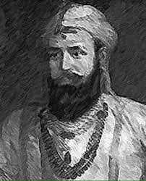**BIMBISARA (546 BC to 494 BC)**

Haryanka is the FIRST DYNASTY of Magadha Kingdom founded by King BIMBISARA. He is the son of BHATTIYA.

It lasted from 544 BC to 413 BC.

He was born in 558 BC & Died in 491 BC.

His wives were KOSALA DEVI , CHELLANA , DHARINI , KHEMA , PADMAVATI , NANDA , AMBAPALI. He got KASI City as Dowry . Thus, VARANASI came under Magadha Control.

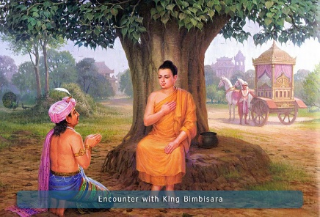Bimbisara is a Great friend & Disciple Of Gautama Buddha.

Haryanka Dynasty followed Hinduism , Jainism & Buddhism.

He is one among 24 TIRTHANKARAs ( Savior & Spiritual Teacher of Religious Path & Dharma) who will be given the Title PADMANABHA / MAHAPADMA.

He followed 3 policies

1. **ANNEXATION**

A formal act of a State Proclaiming its Sovereignty over Territory outside its Domain through wars.

Bimbisara took Control over ANGA kingdom in the same manner.

1. **DIPLOMACY**

It is art of dealing with Situations , People in a sensitive & tactful way by satisfying either sides.

When the King of AVANTI Kingdom , PRATYODHA MAHASENA was

suffering from Jaundice , Bimbisara Sent his Court Scholar cum Physician

JEEVAKA to Cure Pratyodha Mahasena. Impressed by the Kind act of

Bimbisara , Pratyodha gave half of Avanti Kingdom to him.

This is how Bimbisara used the Diplomacy to take Control over Avanti Kingdom , with no war or human loss.

1. **MATRIMONIAL ALLIANCES**  
   Bimbisara got married to 7 women & in return got their kingdoms as the Dowry. That was how he has expanded his control vast & distant regions.

He made the RAJAGRIHA as the first ever capital of his Kingdom in Magadha. While PATALIPUTRA was made the Second Capital & continued as Permanent Capital.

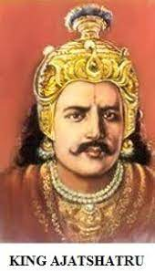His Final days were so Pathetic , as his own son AJATASATRU killed him to take Control Over the Throne & eventually the Kingdom.

**AJATASHATRU (494 BC to 462 BC)**

Ajatasatru is a very ambitious person about the power . He is the First Ever PATRICIDE (One who killed his Own Father) in Indian History .

He Built Pataliputra in 490 BC as a Small Fort near the River Ganga

He followed 3 Policies of his Father Bimbisara. He got married to VAJIRA.

He conquered VATSA , MALLA Kingdoms through War.

KURU, KAMBOJA, VAJJI, MALLA are Republican states while the remaining were Monarchical Kingdoms.

He got Complete Assistance & Cooperation from his Chief Minister cum Army Chief VASSAKARA. They used new War equipment called MAHASHILA KANTAKA & RATHA MUSALA in Wars.

Like his Father Bimbisara, Ajatashatru is also a great admirer & disciple of Gautama Buddha. It is stated in the Buddhist Inscription called BARHUT, that Ajatashatru had fallen on the feet of Gautama Buddha as a Reparation for his Sin of Killing his father.

Soon after Buddha’s death in 483 BC, the 1ST BUDDHIST COUNCIL was organised by Ajatashatru under the Leadership of MAHA KASHYAPA, a Buddhist Monk in the Court of Ajatashatru in Rajagriha. He had widespread the Buddhism towards the 4 corners of Indian Subcontinent, the first Buddhist council was a part of it.

He compiled the Buddhist Religious books by Buddhist Monks ANANDA, UPALI, KAMPA. These books are the Sacred Texts & Preaching of Buddha and Consists of PEETAKAS.

ANANDA compiled SUTTA PITAKA, UPALI compiled VINAYA PEETAKA during the reign of Ajatashatru in the period of Maha Kashyapa. The preachings of Buddha were completely explained in these 2 Pitakas.

ABHINAMMA PITAKA is another one compiled by MOGALIPUTTA TISSA.

Ajatashatru was fallen in Love on AMRAPALI, who was his Court Dancer & India’s First ever Prostitute. She was the First Dancer/Prostitute to become a BUDDHIST NUN.

Ajatashatru had the similar death like his father. UDHAYABHADRA (UDAYIN) , son of Ajatashatru Killed him because of his Greed about Kingdom.

**UDAYIN (462 BC to 444 BC)**

He was also a Prominent King of Haryanka Dynasty, who took forward the development & Beautification of Pataliputra and established it as Capital.

He defeated the King of Avanti multiple times, but was Ultimately killed by him in 444 BC. Puranas states that NANDIVARDHANA as his successor. However, The Sri Lankan Buddhist Chronicles states ANURUDDHA, Udayin’s one of 3 sons as his Successor.

**ANURUDDHA (444 BC to 440 BC)**

Anuruddha was one of 3 sons of Udayin, and also cousin to Gautama Buddha. Later he was Dethroned by his son MUNDA.

**MUNDA (440 BC to 438 BC)**

**NAGADASAKA (438 BC to 413 BC)**

NAGADASAKA was the son of MUNDA , he was the last ruler of Haryanka Dynasty .

He was Killed by his COURTIER “SISHUNAGA” amid the Revolution by people against Nagadasaka in 414 BC , who became king & Founded SISHUNAGA DYNASTY.

**It is evident that all Most of Haryanka Rulers came to power by Killing their Fathers.**

**2. SISHUNAGA DYNASTY (414 BC to 345 BC)**

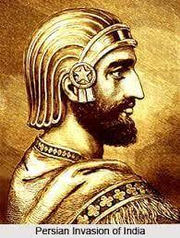 Haryanka Dynasty’s Courtier & Commander in Chief SHISHUNAGA founded SHISHUNAGA DYNASTY by Killing Last Haryanka Ruler NAGADASAKA.

**SISHUNAGA (414 BC to 395 BC)**

He had Completely Merged the AVANTI kingdom into MAGADHA kingdom by Defeating King NANDIVARDHANA, the last Ruler of PRADYOTA DYNASTY . According to the MAHAVAMSATIKA , He was Son of a LICCHAVI Ruler of VAISHALI Kingdom. He was born to a NAGARA SHOBINI and brought by an Officer of State . At the time of People’s revolution against Nagadasaka , He was a Viceroy at Varanasi under Nagadasaka .

Initially, The Capital was RAJAGRIHA , and VAISHALI was his second Royal Residence.

Later , he shifted the capital to VAISHALI .

Puranas tells us that He placed his son KAKAVARNA KALASHOKA as GOVERNOR at VARANASI , and himself ruled from GIRIVRAJA (Rajagriha).

He also Conquered the KOSALA & VATSA kingdoms.

He was Succeeded by his son KALASHOKA.

**KALASHOKA (395 BC to 367 BC)**

During Shishunaga’s reign , Kalashoka was he was GOVERNOR at VARANASI.

He conducted the 2nd Buddhist Council at Vaishali in 383 BC . He made PATALIPUTRA as the Final Capital of the Kingdom.

According to HARSHACHARITA , He was Killed by a Dagger (a short knife with sharp pointed and edged blade) thrust into his Throat in the Vicinity (near) of his Capital.

According to Buddhist Inscriptions , he had 10 sons , who were Ousted (Thrown away) from the UGRASENA MAHAPADMA NANDA .

Those 10 sons Ruled Simultaneously . The MAHABODHIVAMSA states their names as BHADRASENA, KORANDAVARNA, MANGURA, SARVANJAHA, JALIKA, UBHAKA, SANJAYA, KORAVYA, NANDIVARDHANA, PANCHAMAKA.

Puranas Lists **NANDIVARDHANA (367 BC to 355 BC)** as the 9th SHISHUNAGA King, and his son **MAHANANDIN (355 BC to 345 BC)** as the 10th and last Shishunaga King. Mahanandin was killed by MAHAPADMA NANDA , his illegitimate Son who was a BARBER, from a Shudra wife, founded NANDA DYNASTY.

**3.NANDA DYNASTY (345 BC to 322 BC)**

**MAHAPADMA NANDA**

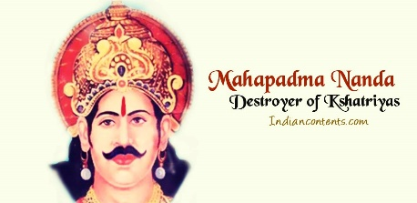It is the First dynasty Established by Shudras. It ruled in the Northern part of the Indian Subcontinent & later spread over all directions during 4th Century BC.

Ancient Sources credit them with Amassing Great Wealth , which was probably a result of Introduction of New Currency and Taxation system.

Ancient Texts also suggests that Nandas were Unpopular among their subjects because of their Low Status Birth , Excessive Taxation , their General Misconduct. The Buddhist tradition called Nandas as ANNATA KULA (Unknown Lineage).

They had great Military Power including 2,00,000 Infantry , 20,000 Cavalry , 2000 War Chariots , 3000 War Elephants. During the ALEXANDER-THE GREAT’s Invasion of Punjab (327 BC to 325 BC) , the GRECO-ROMAN writers depicted the Kingdom as a Great Military Power.

MAHAPADMA NANDA had many Titles SARVA KSHATRANTAK (**for Killing all the Kshatriya Rulers Completely**) , UGRASENA (**For Having Immense Powerful Army**) , PARASURAMA - II .

Except Gandhara & Kambhoja (Both are in Pakistan), All other 14 Mahajanapadas came under NANDAs Control and merged into Magadha.

Mahapadma Nanda attacked KALINGA kingdom , and abducted the JAIN statues over there , and installed them in Magadha.

Nandas ruled for 2 generations and had 9 rulers including Mahapadma Nanda, who were all BROTHERS.

PANDUKA

PANDUGATI

BHUTA PALA

RASHTRA PALA

GOVISHANAKA

DASHA SIDDHAKA

KAIVARTA

**DHANA NANDA (329 BC to 322 BC)**

DHANA NANDA was the last Nanda Ruler .

During its peak period , NANDA empire expanded from PUNJAB in West to ODISHA in East.

CHANDRAGUPTA MAURYA along with CHANAKYA killed Dhana Nanda in Pataliputra after Capturing Border Villages. And Founded MAURYAN EMPIRE.

**MAURYAN EMPIRE (321 BC to 185 BC)**

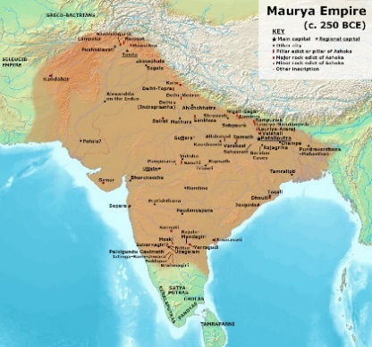CHANAKYA also called as KAUTILYA & VISHNUGUPTA was an ancient Indian Polymath who was a Teacher, Author, Strategist, Philosopher, Economist, Jurist & Royal Advisor.

He was Brahmin by birth, and was a Teacher & Scholar at TAXILA UNIVERSITY

He was insulted by DHANA NANDA , to take revenge on him, Chanakya Made a pledge that he will take down Dhana Nanda from the Throne & will replace him another person who is capable to Rule. Then , He saw CHANDRAGUPTA MAURYA…trained him…made him to defeat Dhana Nanda in 321 BC and become a King. That is why Chanakya is called as KINGMAKER. Chandragupta Made Chanakya as his Prime Minister.

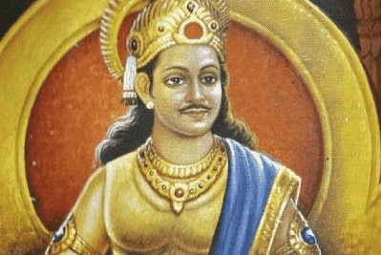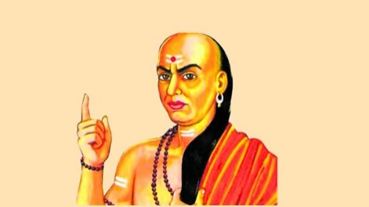

Chanakya Wrote Administration Related ARDHASHASTRA (ECONOMICS) which contains 15 Books & 180 Chapters in detail In Sanskrit Language around 2nd Century BC. The main themes are divided into

* KING, COUNCIL OF MINISTERS, DEPARTMENTS OF GOVERNMENT
* CIVIL & CRIMINAL LAW
* WAR DIPLAMOCY

It also Contains information on TRADE & MARKETS, a method to Screen MINISTERS, SPIES, DUTIES OF A KING, ETHICS, SOCIAL WELFARE, AGRICULTURE, MINING, METALLURGY, MEDICINE, FORESTS etc.,

Chanakya was Awarded as INDIAN MACHIAVELLI.

NICCOLO MACHIAVELLI was an ITALIAN philosopher who wrote Political Treatise THE PRINCE , Chanakya’s Ardhashastra is compared with THE PRINCE book.

ARDHASHASTRA got disappeared in the 12th Century & was Rediscovered but partially by R SHAMASHASTRY who was a librarian in 1905.

Mauryans continued PATALIPUTRA as their Capital. Pataliputra was also Called as KUSUMAPURAM.

MAGADHI PRAKRIT was the Official Language of Mauryans.

MAURYAN KINGDOM was the FIRST LARGEST EMPIRE & Chandragupta Maurya was the FIRST NATIONAL EMPEROR.

**CHANDRAGUPTA MAURYA (321 BC to 298 BC)**

CHANDRAGUPTA defeated SELEUCAS I NICATOR in 305 BC who was a MACEDNIAN GREEK GENERAL , and also the Successor of Alexander. Seleucas I Nicator got his Daughter HELENA married to Chandragupta & also sent his ambassador MEGASTHANIS to the Court of Chandragupta , Megasthanis was the First Embassador to visit India. Thus Chandragupta Secured his Western Border by defeating Nicator.

Prior (Before) to his consolidation of power, ALEXANDER had invaded NORTH WEST Indian Subcontinent before abandoning his campaign in 324 BC due to Mutiny (Revolt) caused by prospect of facing another large empire , Presumably Nanda Empire.

Chandragupta defeated & conquered both the Nanda & Greek Satraps (Settlements) that were appointed or formed from Alexander’s Empire in SOUTH ASIA.

Chandragupta’s reign extended throughout most of the Indian Subcontinent, spanning from Modern day BENGAL to AFGHANISTAN, Across North India as Well making inroads into Central & South India .

Contemporary Greek evidence states that Chandragupta didn’t give up performing the Rites of ANIMAL SACRIFISE associated with Vedic Brahmanism. He was delighted in Hunting and otherwise leading a life Remote from the Jain Practice of AHIMSA towards Living Beings.

Chandragupta’s reign & Mauryan Empire set an era of Economic Prosperity, Reforms, Infrastructure expansions, and Tolerance

DURDHARA was the first wife of Chandragupta , she gave birth to BINDUSARA AMITRAGATHA.

Chandragupta dug SUDARSHANA LAKE which is now present in Gujarat, later ASHOKA made repairs to it.

Greeks used to call Chandragupta as SANDRA KOTES.

Buddha Book MAHAVAMSA mentioned Chandragupta as a Kshatriya Ruler. He led a Vast army of 6,00,000 soldiers.

He adopted Jainism from Jain saint BHADRABAHU , and went to SRAVANA BELAGOLA in Karnataka and did SALLEKHANA Ritual which includes Fasting. It is being said that Chandragupta Died here because of Fasting to Death.

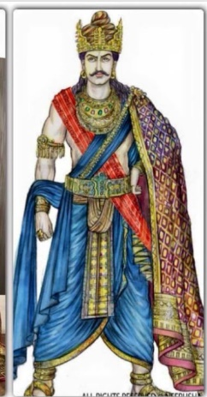**BINDUSARA AMITRAGATHA (298 BC to 272 BC)**

BINDUSARA is the son of Chandragupta & Dhurdhara. He got married to SUBHADRANGI. According to Sri Lankan Buddhist books MAHAVAMSA & DEEPAVAMSA, Bindusara had 100 sons, ASHOKA was one of them , killed his 99 Brothers to Take over the Throne (It is a Controversial topic, as there are no Strong evidences of Ashoka killing his 99 Brothers)

He adopted AJEEVIKA Sect which is started by MAKKALI GHOSHALI , and is a branch of Jainism. He followed it by inspiring from the Statement “ Anything will happen as it is Written”.

He was given 2 titles

* AMITRAGATHA , Greeks used to call him as AMITROCHATES
* SIMHASENA

A Syrian ruler Called ANTIMOCHUS sent an ambassador named “DAMAICUS” to Bindusara.

Bindusara’s Prime Minister was KHALLATAKUDU. And , there was a AJEEVIKA ASTROLOGIST called PINGALI VATSA in Bindusara’s Court.

Bindusara appointed his son ASHOKA as GOVERNOR of UJJAINI. Ashoka was sent to Taxila during Taxila Revolt, and he efficiently controlled the Situation.

A Tibetan Buddhist Author TARANATH stated that Bindusara’s Reign is extended Till Mysore to the land between 2 seas i.e., to the whole Southern India which is between Arabian Sea & Bay of Bengal.

He died after being Tricked into a Pit of Burning Charcoal by Ashoka’s Well-wisher RADHAGUPTA . The RAJAVALI KATHA states that Bindusara retired after handing over the Throne to his son Ashoka.

**ASHOKA MAURYA (269 BC to 232 BC)**

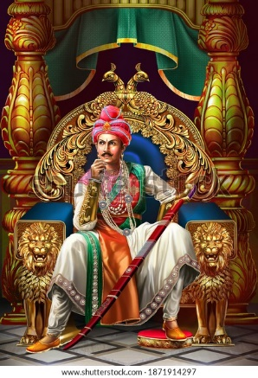Ashoka Defeated KALINGA Rulers in DHOULI (near Bhubaneshwar) WAR in 261 BC. But, seeing the Massive Bloodshed of Both Side’s Warriors on the War field, he got depressed . He considered his win as a personal defeat because of Loss of Many lives.

Then he had Chosen NON VIOLENCE Path and adopted BUDDHISM inspired by a Buddhist Monk NIGRODHA UPAGUPTA

MASKI & GUJARA Pillars in MADHYA PRADESH has Inscriptions that Refer to Ashoka as DEVANAMPRIYA / PRIYADASI which means Beloved of Gods.

Ashoka conducted 3rd Buddhist Council in 250 BC in PATALIPUTRA under the Presidentship of MOGALIPUTA TISSA.

Ashoka had 3 Wives MAHARANI DEVI , ASANDHIMITRA , TISHYARAKSHA.

He had 6 Children MAHENDRA, SANGHAMITRA, KUNALA, CHARUMATI, TIVALA, JALUKA.

Ashoka sent different ambassadors to different Countries to Promote Buddhism

**SRI LANKA**

* Ashoka’s Daughter **SANGHAMITRA**
* Ashoka’s Son **MAHENDRA**

**BURMA**

* **SONA**
* **UTTARA**

**NEPAL**

* Ashoka’s Daughter **CHARUMATI**

**CHINA**

* **UPAGUPTA**

**MYSORE**

* **MAHADEVA**

**HIMALAYAS**

* **MAJJIMA**

**GREEK PLACES**

* **MAHARAKKITA**

**KASHMIR & GANDHARA**

* **MADHYANTIKA**

**MAHARASHTRA**

* **MAHADHARMA RAKKITA**

Ashoka was the First Indian King to issue ROCK INSCRIPTIONS. Almost 181 Rock Inscriptions of Ashoka were found in around 47 Places. His Inscriptions are of 2 types

* 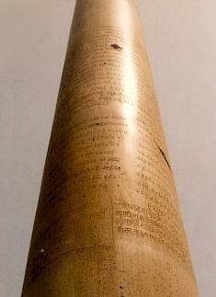PILLAR INSCRIPTIONS

7 Pillar Inscriptions of Ashoka were found at

1. RAMPURVA in Bihar
2. TOPRA
3. MEERUT
4. LAURYA NANDANGARH
5. ALLAHABAD
6. SARANADH
7. LUMBINI / RUMMINDAI

* ROCK INSCRIPTIONS

MAJOR ROCK EDICT IV of Ashoka explains about his Practice of Dharma

MAJOR ROCK EDICT XII of Ashoka explains about his Conquest of Kalinga, where he mentioned “ ALL MAN ARE AS MY CHILDREN” .

Chinese Ambassador I-TSING said that he saw Ashoka’s Statue as a Buddhist Monk.